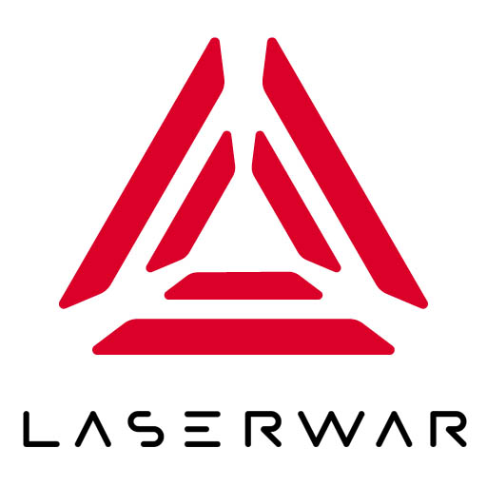
ОБЩЕСТВО С ОГРАНИЧЕННОЙ ОТВЕТСТВЕННОСТЬЮ
«ЛАЗЕРТАГ»

ПАСПОРТ

Смоленск
LIMITED LIABILITY COMPANY
LASERWAR

THE NUCLEAR BRIEFCASE “PERIMETER”

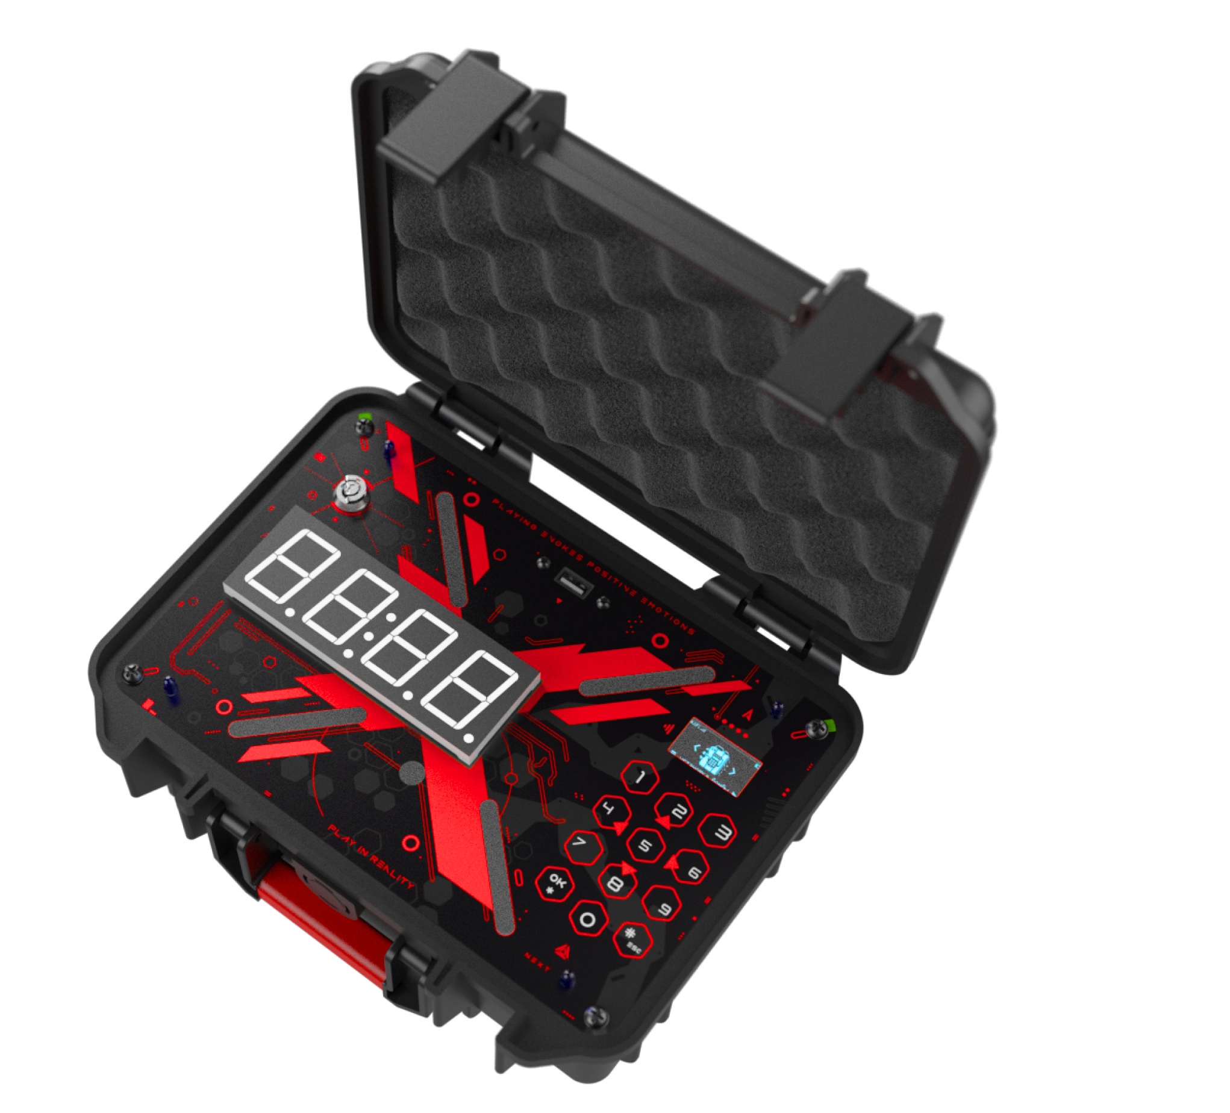

SPECIFICATION

Dear Customer!
Our company welcomes and thanks you for the decision to buy our products, and is confident that the purchased device will bring you a long-term pleasure. The warranty certificate establishes the guarantee of the product in the amount provided for by the Law on consumer protection of the Russian Federation.
This warranty certificate is valid for 12 months from the purchase date of the product, and is subject to the guarantee terms.
Warranty Terms:
1. The guarantee is effective upon presentation of this coupon, which shall contain the serial number of the product and the date of its purchase, confirmed by the service centre.
2. These guarantee obligations apply to products acquired only from the official LASERTAG representative or the official dealer.
3. The present guarantee is invalid if the product deficiencies have occurred in the following cases:
- failure to comply with Operating instructions;
- mechanical damage;
- penetration of extraneous items, liquids, etc.;
- animal activities;
- unauthorized access to the parts of the game set by non-authorized persons;
- use of the product for purposes for which it hasn't been made;
- Acts of elements (natural disaster, fire, accidents, etc.);
- the game set malfunction in case of faulty power network and/or poor care of the product.
4. If the warranty certificate is lost, no duplicate is issued.

8. Guarantee obligations
The manufacturer guarantees the reliability of the operation of an individual LASERWAR set if the consumer has complied with the conditions of use. Technical support is provided within 12 months of the sale date. The manufacturer undertakes to replace or repair an individual set of equipment free of charge, if the customer has complied with the rules for the device transportation, storage, operation and delivery of defective equipment to Smolensk City.

9. Contact information

Official website:
www.laserwar.com

E-mail: Purchase Date: _________________________
info@laserwar.com
help@laserwar.com

Skype:
info@laserwar.com
help@laserwar.com

______________________________________
signature

2
7
Information on the repairs performed during the maintenance period (completed by the Service centre performing the warranty repair works)

Date:__________________  Completed work: _____________________________________________________________________  Service centre stamp | Date:__________________  Completed work: _____________________________________________________________________  Service centre stamp
Date:__________________  Completed work: _____________________________________________________________________  Service centre stamp | Date:__________________  Completed work: _____________________________________________________________________  Service centre stamp
Date:__________________  Completed work: _____________________________________________________________________  Service centre stamp | Date:__________________  Completed work: _____________________________________________________________________  Service centre stamp

- Description
The Nuclear briefcase (NB) “Perimeter” represents an explosive device simulator, which is used for different game scenarios. Turning on and reboot of the NB “Perimeter” is carried out with the help of the key. All the settings can be changed in the administrator menu. The information is shown on two screens: segment (for time calculating) and LCD (for all menus, entering passwords, etc.).
- Scope of application
The device itself is an imitator of explosive device and used in different laser tag events, tactical trainings, corporate and entertaining events.

- Set delivery
- NB “Perimeter” – 1 pc.
- Activation key – 2 pcs.
- Manual – 1 pc.

- Main technical data

Height, mm | 160
Width, mm | 260
Thickness, mm | 210
Supply voltage, V | 7.4
Battery capacity, mAh | 3000
Number of IR emitters, pcs. | 1
Weight, kg | 1

3
6
- Device
The Nuclear briefcase “Perimeter” is made in plastic black case.
The main body is a structure in which a power supply element, control units, and module fastening elements are installed. There is a power led, sounder, two information displays, numeric keypad, power socket, battery charging port on the case.

- Technical maintenance
For normal work of equipment you need to treat all the set elements carefully. You also should avoid contamination of IR emitters. Do not allow moisture to enter the housing. Charge the batteries timely. The kit is recharged using a charger (the charger is not included in the delivery set and must be purchased separately). Avoid impacts.

- Changing tactical and technical characteristics of the game set.
The Nuclear briefcase (NB) “Perimeter”
The nuclear briefcase is turned on and off by turning a key, which is kept by the instructor during the game. After turning on the label LASERWAR will appear on the screen and the main menu with scenarios will open. The device's charge level and Wi-Fi connection strength will also be displayed.
The device is set up by two ways: manually or with the help Alfatag-configurator. The settings in both variants are similar. Soft connection is necessary for online gaming. In this case, check the Wi-Fi connection in the device, the name of the network must be same as the router has.
To switch to the settings mode without connecting to the software, turn on the Nuclear Briefcase by turning the key, find the appropriate menu item and press *. The settings are divided into 4 units.
The setup process is described in detail in the "Manual" posted on the product page in the LASERWAR online store.

Equipment Maintenance Rules
1. Weather conditions. At the course of manufacture we make different tests to see how well the equipment works under different weather conditions. Despite this, we strongly recommend that the equipment shouldn't be used in the rain and at temperatures below -20 °C.
What should I know when using the equipment in poor weather conditions?
The most important thing is to avoid getting moisture inside the device. If this happened, turn off the device, dry the equipment at room temperature for at least two hours.

2. Power source. Lithium batteries are used as a source of power in the Pandora Box game set.
The box and activator are charged by any Li+ charger from LASERWAR.
The "radioactive" tube must be charged with a micro-USB charger.

3. Storage conditions. It is necessary to store the equipment in a well-ventilated room at temperature from + 18 °C to + 30 °C and relative humidity of 45-65%.
The warranty is 14 days for speakers, and IR modules. These components are expendable materials.

WARNING! In the case of improper operation of the accumulator (charging by an unrelated type of a charger), the warranty doesn't cover the battery!

4
5

